ADVISING - Kutcher/Sicard - Centre for Analytics
S. Kutcher, V. Sicard, A. Dodd (ft. R. Belaghi) – 15-May-2026 at 00:55
/share/team/cru/users/Stephen/20250052-Kutcher-CfA/Analysis/cfa_cleaned.Rmd – rev 15 with changes [last commit 04-May-2026 at 16:30]

R Packages
# libraries
library(dplyr)
library(tidyr)
library(caret)
library(scales)
library(gtsummary)
library(flextable)
library(NbClust)
library(ggplot2)
library(factoextra) # fviz_cluster
# devtools::install_github("ricardo-bion/ggradar", dependencies = TRUE)
library(ggradar)
library(dendextend)
## integer(0)

Data preparation
# Data preparation
n.row <- nrow(data_tilt.ortho) # number of participants = 266
n.col <- ncol(data_tilt.ortho) # number of columns = 80
print(c('Number of participants', n.row))
## [1] "Number of participants" "266"
print(c('Number of variables', n.col))
## [1] "Number of variables" "80"
# identify columns with low variance (sparse data)
remove_columns <- nearZeroVar(data_tilt.ortho)
# drop those columns
data_tilt.ortho <- data_tilt.ortho |>
select(-all_of(remove_columns),
# drop non-continuous / non-binary data
-c(Mechanism:`Loss of consciousness`)
)
# N = 266; columns = 41
n.row <- nrow(data_tilt.ortho) # number of participants = 266
n.col <- ncol(data_tilt.ortho) # number of columns = 80
print(c('Number of participants', n.row))
## [1] "Number of participants" "266"
print(c('Number of variables', n.col))
## [1] "Number of variables" "41"
# print first 5 rows and 6 columns
data_tilt.ortho[1:5, 1:6]
## # A tibble: 5 × 6
## Age Sex `Days since injury` education_code Asthma Migraines
## <int> <dbl> <dbl> <int> <int> <int>
## 1 14 1 61 9 0 0
## 2 17 1 16 15 0 0
## 3 23 0 346 19 0 0
## 4 46 1 40 19 0 0
## 5 20 1 38 22 0 0
# Scale the data for ML modelling
scale_tilt.ortho <- as.data.frame(scale(data_tilt.ortho))
# print first 5 rows and 6 columns
scale_tilt.ortho[1:5, 1:6]
## Age Sex Days since injury education_code Asthma Migraines
## 1 -1.1039345 0.756179 0.04700973 -1.8318755 -0.3625175 -0.4137152
## 2 -0.9064586 0.756179 -0.15056980 -0.6306950 -0.3625175 -0.4137152
## 3 -0.5115070 -1.317467 1.29834678 0.1700920 -0.3625175 -0.4137152
## 4 1.0024745 0.756179 -0.04519405 0.1700920 -0.3625175 -0.4137152
## 5 -0.7089828 0.756179 -0.05397536 0.7706822 -0.3625175 -0.4137152

Results

Table 1: Study population characteristics
# create a table of participant characteristics
# prepare table 1 data
# calculate autonomic dysregulation outcome & rename education levels for presentation simplicity
table_1_dat <- data_tilt.ortho |>
mutate(
# AD tilt (objective)
AD = ifelse(
# Decrease in DBP of at least 10 mm Hg
(TiltStandingDBP - TiltLyingDBP)<=-10 |
(StandingDBP_1_Minute-TiltLyingDBP)<=-10 |
(StandingDBP_2_Minute - TiltLyingDBP)<=-10 |
(StandingDBP_3_Minute - TiltLyingDBP)<=-10 |
# Decrease in SBP of at least 20 mm Hg
(TiltStandingSBP - TiltLyingSBP)<=-20 |
(StandingSBP_1_Minute-TiltLyingSBP)<=-20 |
(StandingSBP_2_Minute - TiltLyingSBP)<=-20 |
(StandingSBP_3_Minute - TiltLyingSBP)<=-20 |
# Increase in HR of at least 40 bpm (ages 16-19) or 30 bpm (ages 19+)
(Age>19 & (TiltStandingHR - TiltLyingHR)>=30) |
(Age>19 &
(StandingHR_1_Minute-TiltLyingHR )>=30) |
(Age>19 &
(StandingHR_2_Minute - TiltLyingHR )>=30) |
(Age>19 &
(StandingHR_3_Minute - TiltLyingHR )>=30) |
(Age<=19 & (TiltStandingHR - TiltLyingHR )>=40) |
(Age<=19 & (StandingHR_1_Minute-TiltLyingHR)>=40) |
(Age<=19 &
(StandingHR_2_Minute - TiltLyingHR)>=40) |
(Age<=19 &
(StandingHR_3_Minute - TiltLyingHR)>=40), 1, 0),
# AD (subjective)
AD_subjective = case_when(symptom_provocation == 1 |
symptom_exacerbation == 1 ~ 1,
TRUE ~0),
education = case_when(
education_code == 1 ~ "Never attended / Kindergarten only",
education_code == 2 ~ "1st Grade",
education_code == 3 ~ "2nd Grade",
education_code == 4 ~ "3rd Grade",
education_code == 5 ~ "4th Grade",
education_code == 6 ~ "5th Grade",
education_code == 7 ~ "6th Grade",
education_code == 8 ~ "7th Grade",
education_code == 9 ~ "8th-12th Grade",
education_code == 10 ~ "8th-12th Grade",
education_code == 11 ~ "8th-12th Grade",
education_code == 12 ~ "8th-12th Grade",
education_code == 13 ~ "8th-12th Grade",
education_code == 14 ~ "OAC/13th Grade",
education_code == 15 ~ "High school graduate",
education_code == 16 ~ "CEGEP Year 1",
education_code == 17 ~ "Some college/University",
education_code == 18 ~ "GED or equivalent",
education_code == 19 ~ "Some college/University",
education_code == 20 ~ "Some college/University",
education_code == 21 ~ "Some college/University",
education_code == 22 ~ "Bachelor's degree",
education_code == 23 ~ "MSc/PhD degree",
education_code == 24 ~ "Professional school degree",
education_code == 25 ~ "MSc/PhD degree",
education_code == 9999 ~ "Do not know",
TRUE ~ NA_character_),
education = factor(education, levels=c(
"8th-12th Grade",
"High school graduate",
"Some college/University",
"Bachelor's degree",
"MSc/PhD degree"
))
)
# create table 1
table1 <- table_1_dat |>
select(
Age,
Sex,
education,
gad_tot,
phq9_tot,
bess_tandem_error,
SCAT5SymptmEvalTotSymptmScore,
AD,
AD_subjective
) |>
tbl_summary(
statistic = list(
all_continuous() ~ "{median} ({p25}, {p75})",
all_categorical() ~ "{n} ({p}%)"
),
label = list(
Age = "Age, years",
Sex = "Female",
education = "Education",
SCAT5SymptmEvalTotSymptmScore = "SCAT6 Symptom score (0-132)",
AD = "Autonomic dysregulation (orthostatic vitals)",
AD_subjective = "Autonomic dysregulation (symptom provocation)",
gad_tot = "GAD-7 (Anxiety)",
phq9_tot = "PHQ-9 (Depression)",
bess_tandem_error ="BESS tandom error score"
),
missing_text = "Missing"
)
# print table 1
table1
Characteristic | N = 266¹
Age, years | 28 (17, 41)
Female | 169 (64%)
Education
8th-12th Grade | 78 (30%)
High school graduate | 10 (3.9%)
Some college/University | 68 (26%)
Bachelor's degree | 66 (25%)
MSc/PhD degree | 37 (14%)
Missing | 7
GAD-7 (Anxiety) | 8 (4, 14)
PHQ-9 (Depression) | 11 (7, 16)
BESS tandom error score | 1 (0, 4)
SCAT6 Symptom score (0-132) | 19 (14, 21)
Autonomic dysregulation (orthostatic vitals) | 47 (18%)
Autonomic dysregulation (symptom provocation) | 155 (58%)
¹Median (Q1, Q3); n (%)

Analysis: Hierarchical agglomerative clustering
# NbClust function: to determine the best partition to optimize of the number of clusters
res_nbclust <- NbClust(scale_tilt.ortho,
distance = "euclidean",
min.nc=2, max.nc=10,
method = "ward.D2",
index = "alllong")
## *** : The Hubert index is a graphical method of determining the number of clusters.
## In the plot of Hubert index, we seek a significant knee that corresponds to a
## significant increase of the value of the measure i.e the significant peak in Hubert
## index second differences plot.
##
## *** : The D index is a graphical method of determining the number of clusters.
## In the plot of D index, we seek a significant knee (the significant peak in Dindex
## second differences plot) that corresponds to a significant increase of the value of
## the measure.
##
## *******************************************************************
## * Among all indices:
## * 4 proposed 2 as the best number of clusters
## * 3 proposed 3 as the best number of clusters
## * 7 proposed 4 as the best number of clusters
## * 1 proposed 6 as the best number of clusters
## * 3 proposed 7 as the best number of clusters
## * 3 proposed 8 as the best number of clusters
## * 3 proposed 9 as the best number of clusters
## * 3 proposed 10 as the best number of clusters
##
## ***** Conclusion *****
##
## * According to the majority rule, the best number of clusters is 4
##
##
## *******************************************************************
# identify and store the most frequently recommended cluster size
out_nbclust <- as.data.frame(res_nbclust$Best.nc) |>
slice(1) |>
pivot_longer(
cols = KL:SDbw,
names_to = 'indice',
values_to = 'cluster'
)
cluster_size = as.numeric(names(sort(-table(out_nbclust$cluster)))[1])
# Run the hierarchical agglomerative clustering machine learning model
# Create a dissimilarity matrix
d2 <- dist(scale_tilt.ortho, method = "euclidean")
# Hierarchical agglomerative clustering using Ward's D2 method
hc_tilt <- hclust(d2, method = "ward.D2" )
# Cut the clustering tree into the number of groups from NbClust()
clust_grp <- cutree(hc_tilt, k = cluster_size)
# store subgroup results in a dataframe
clust_grp_dat <- as.data.frame(clust_grp)
# store the clustering results in the unscaled and scaled data sets
data_tilt.ortho_clust <- data_tilt.ortho |>
bind_cols(clust_grp_dat)
# store in scaled data
scale_tilt.ortho_clust <- scale_tilt.ortho |>
bind_cols(clust_grp_dat)

Table of patient characteristics by the clustering levels
# calculate autonomic dysregulation
data_tilt.ortho_clust <- data_tilt.ortho_clust |>
mutate(
grp4_cluster = as.factor(clust_grp),
# AD tilt (objective)
AD = ifelse(
# Decrease in DBP of at least 10 mm Hg
(TiltStandingDBP - TiltLyingDBP)<=-10 |
(StandingDBP_1_Minute-TiltLyingDBP)<=-10 |
(StandingDBP_2_Minute - TiltLyingDBP)<=-10 |
(StandingDBP_3_Minute - TiltLyingDBP)<=-10 |
# Decrease in SBP of at least 20 mm Hg
(TiltStandingSBP - TiltLyingSBP)<=-20 |
(StandingSBP_1_Minute-TiltLyingSBP)<=-20 |
(StandingSBP_2_Minute - TiltLyingSBP)<=-20 |
(StandingSBP_3_Minute - TiltLyingSBP)<=-20 |
# Increase in HR of at least 40 bpm (ages 16-19) or 30 bpm (ages 19+)
(Age>19 & (TiltStandingHR - TiltLyingHR)>=30) |
(Age>19 &
(StandingHR_1_Minute-TiltLyingHR )>=30) |
(Age>19 &
(StandingHR_2_Minute - TiltLyingHR )>=30) |
(Age>19 &
(StandingHR_3_Minute - TiltLyingHR )>=30) |
(Age<=19 & (TiltStandingHR - TiltLyingHR )>=40) |
(Age<=19 & (StandingHR_1_Minute-TiltLyingHR)>=40) |
(Age<=19 &
(StandingHR_2_Minute - TiltLyingHR)>=40) |
(Age<=19 &
(StandingHR_3_Minute - TiltLyingHR)>=40), 1, 0),
# AD (subjective)
AD_subjective = case_when(symptom_provocation == 1 |
symptom_exacerbation == 1 ~ 1,
TRUE ~0),
education = case_when(
education_code == 1 ~ "Never attended / Kindergarten only",
education_code == 2 ~ "1st Grade",
education_code == 3 ~ "2nd Grade",
education_code == 4 ~ "3rd Grade",
education_code == 5 ~ "4th Grade",
education_code == 6 ~ "5th Grade",
education_code == 7 ~ "6th Grade",
education_code == 8 ~ "7th Grade",
education_code == 9 ~ "8th-12th Grade",
education_code == 10 ~ "8th-12th Grade",
education_code == 11 ~ "8th-12th Grade",
education_code == 12 ~ "8th-12th Grade",
education_code == 13 ~ "8th-12th Grade",
education_code == 14 ~ "OAC/13th Grade",
education_code == 15 ~ "High school graduate",
education_code == 16 ~ "CEGEP Year 1",
education_code == 17 ~ "Some college/University",
education_code == 18 ~ "GED or equivalent",
education_code == 19 ~ "Some college/University",
education_code == 20 ~ "Some college/University",
education_code == 21 ~ "Some college/University",
education_code == 22 ~ "Bachelor's degree",
education_code == 23 ~ "MSc/PhD degree",
education_code == 24 ~ "Professional school degree",
education_code == 25 ~ "MSc/PhD degree",
education_code == 9999 ~ "Do not know",
TRUE ~ NA_character_),
education = factor(education, levels=c(
"8th-12th Grade",
"High school graduate",
"Some college/University",
"Bachelor's degree",
"MSc/PhD degree",
"Professional school degree"
)),
n_symp_lying = as.numeric(n_symp_lying),
n_symp_standing_0min = as.numeric(n_symp_standing_0min),
n_symp_standing_1min = as.numeric(n_symp_standing_1min),
n_symp_standing_2min = as.numeric(n_symp_standing_2min),
n_symp_standing_3min = as.numeric(n_symp_standing_3min)
)
# Table 1 stratified by cluster
table1 <- data_tilt.ortho_clust |>
select(
Age,
Sex,
`Days since injury`,
Migraines,
Anxiety,
SCAT5SymptmEvalTotSymptmScore,
symptom_provocation,
symptom_exacerbation,
S1_SDNN:S2_RMSSD,
grp4_cluster,
AD,
AD_subjective
)
table_cluster <- table1 |>
tbl_summary(
by = grp4_cluster, # Splits by grp cluster
type = list(
all_continuous() ~ "continuous2"
),
statistic = list(
all_continuous() ~ "{median} ({p25}, {p75})",
all_categorical() ~ "{n} ({p}%)"
),
label = list(
Age = "Age, years",
Sex = "Female",
SCAT5SymptmEvalTotSymptmScore = "Symptom score (0-132)",
AD = "Autonomic dysregulation (vitals)",
AD_subjective = "Autonomic dysregulation (symptom provocation)"
),
missing_text = "Missing"
) |>
add_p() |>
add_overall()
# print table
table_cluster
Characteristic | Overall N = 266¹ | 1 N = 120¹ | 2 N = 81¹ | 3 N = 38¹ | 4 N = 27¹ | p-value²
Age, years |  |  |  |  |  | <0.001
Median (Q1, Q3) | 28 (17, 41) | 27 (18, 38) | 31 (24, 47) | 15 (14, 16) | 40 (29, 57)
Female | 169 (64%) | 96 (80%) | 56 (69%) | 10 (26%) | 7 (26%) | <0.001
Days since injury |  |  |  |  |  | <0.001
Median (Q1, Q3) | 18 (10, 38) | 17 (12, 39) | 22 (15, 41) | 8 (5, 15) | 19 (10, 49)
Migraines | 39 (15%) | 8 (6.7%) | 25 (31%) | 5 (13%) | 1 (3.7%) | <0.001
Anxiety | 108 (41%) | 38 (32%) | 59 (73%) | 2 (5.3%) | 9 (33%) | <0.001
Symptom score (0-132) |  |  |  |  |  | <0.001
Median (Q1, Q3) | 19 (14, 21) | 20 (17, 22) | 19 (15, 21) | 11 (4, 15) | 18 (14, 22)
symptom_provocation | 35 (13%) | 1 (0.8%) | 21 (26%) | 12 (32%) | 1 (3.7%) | <0.001
symptom_exacerbation | 120 (45%) | 80 (67%) | 32 (40%) | 1 (2.6%) | 7 (26%) | <0.001
S1_SDNN |  |  |  |  |  | <0.001
Median (Q1, Q3) | 168 (81, 252) | 194 (115, 268) | 120 (65, 185) | 268 (197, 313) | 82 (43, 156)
S1_RMSSD |  |  |  |  |  | <0.001
Median (Q1, Q3) | 166 (86, 251) | 179 (105, 256) | 136 (78, 216) | 242 (135, 296) | 96 (59, 145)
S2_SDNN |  |  |  |  |  | <0.001
Median (Q1, Q3) | 170 (80, 263) | 198 (123, 271) | 104 (44, 190) | 257 (174, 314) | 95 (45, 231)
S2_RMSSD |  |  |  |  |  | 0.11
Median (Q1, Q3) | 166 (82, 251) | 177 (103, 245) | 135 (69, 259) | 223 (117, 280) | 123 (55, 216)
Autonomic dysregulation (vitals) | 47 (18%) | 25 (21%) | 12 (15%) | 7 (18%) | 3 (11%) | 0.6
Autonomic dysregulation (symptom provocation) | 155 (58%) | 81 (68%) | 53 (65%) | 13 (34%) | 8 (30%) | <0.001
¹n (%)
²Kruskal-Wallis rank sum test; Pearson's Chi-squared test; Fisher's exact test

Figures to visualize and explore the clustering

Dendogram
dend <- as.dendrogram(hc_tilt)
d1=color_branches(dend,
k=cluster_size,
col = c("#E69F00","#56B4E9", "#009E73", "#CC79A7"))
par(mfrow=c(1,1))
plot(d1)
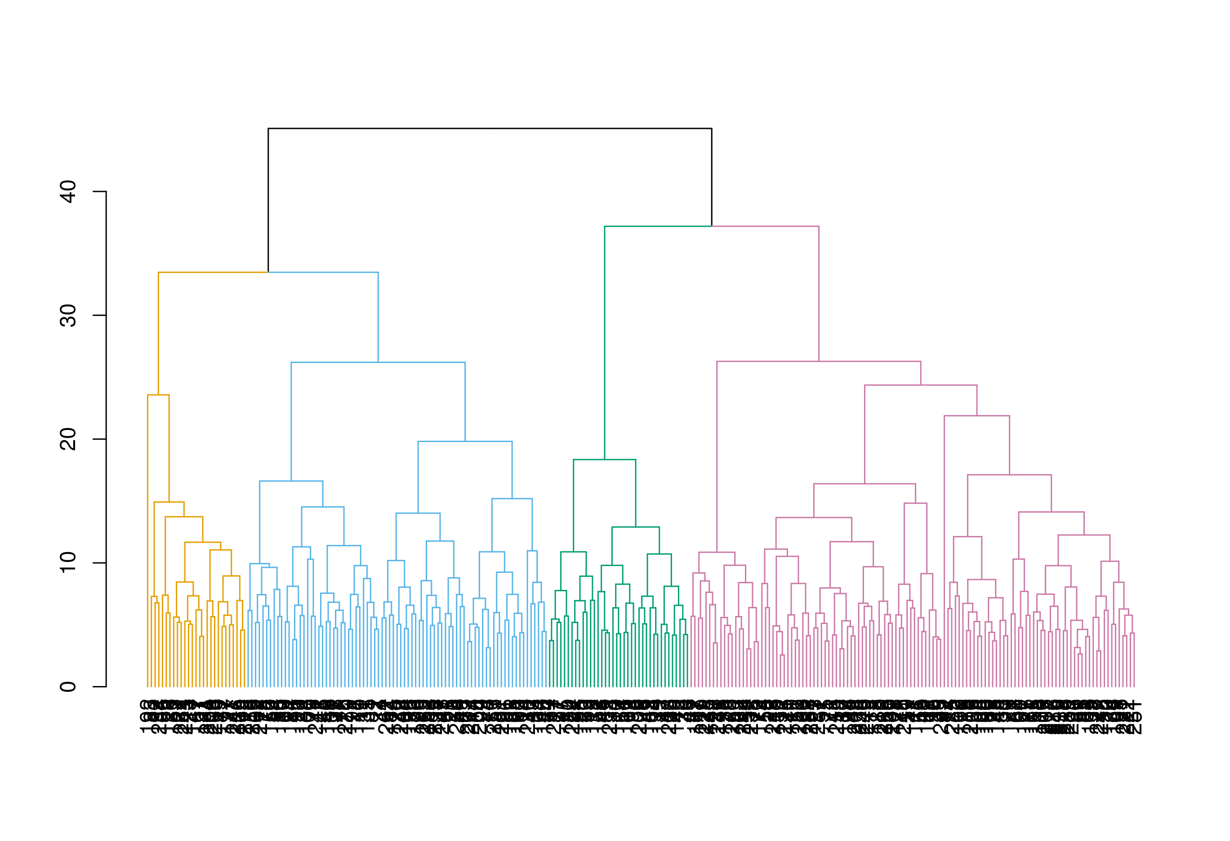

2-D spacial plot
fviz_cluster(list(data = scale_tilt.ortho,
cluster = clust_grp),
palette = c("#E69F00","#56B4E9", "#009E73", "#CC79A7"))
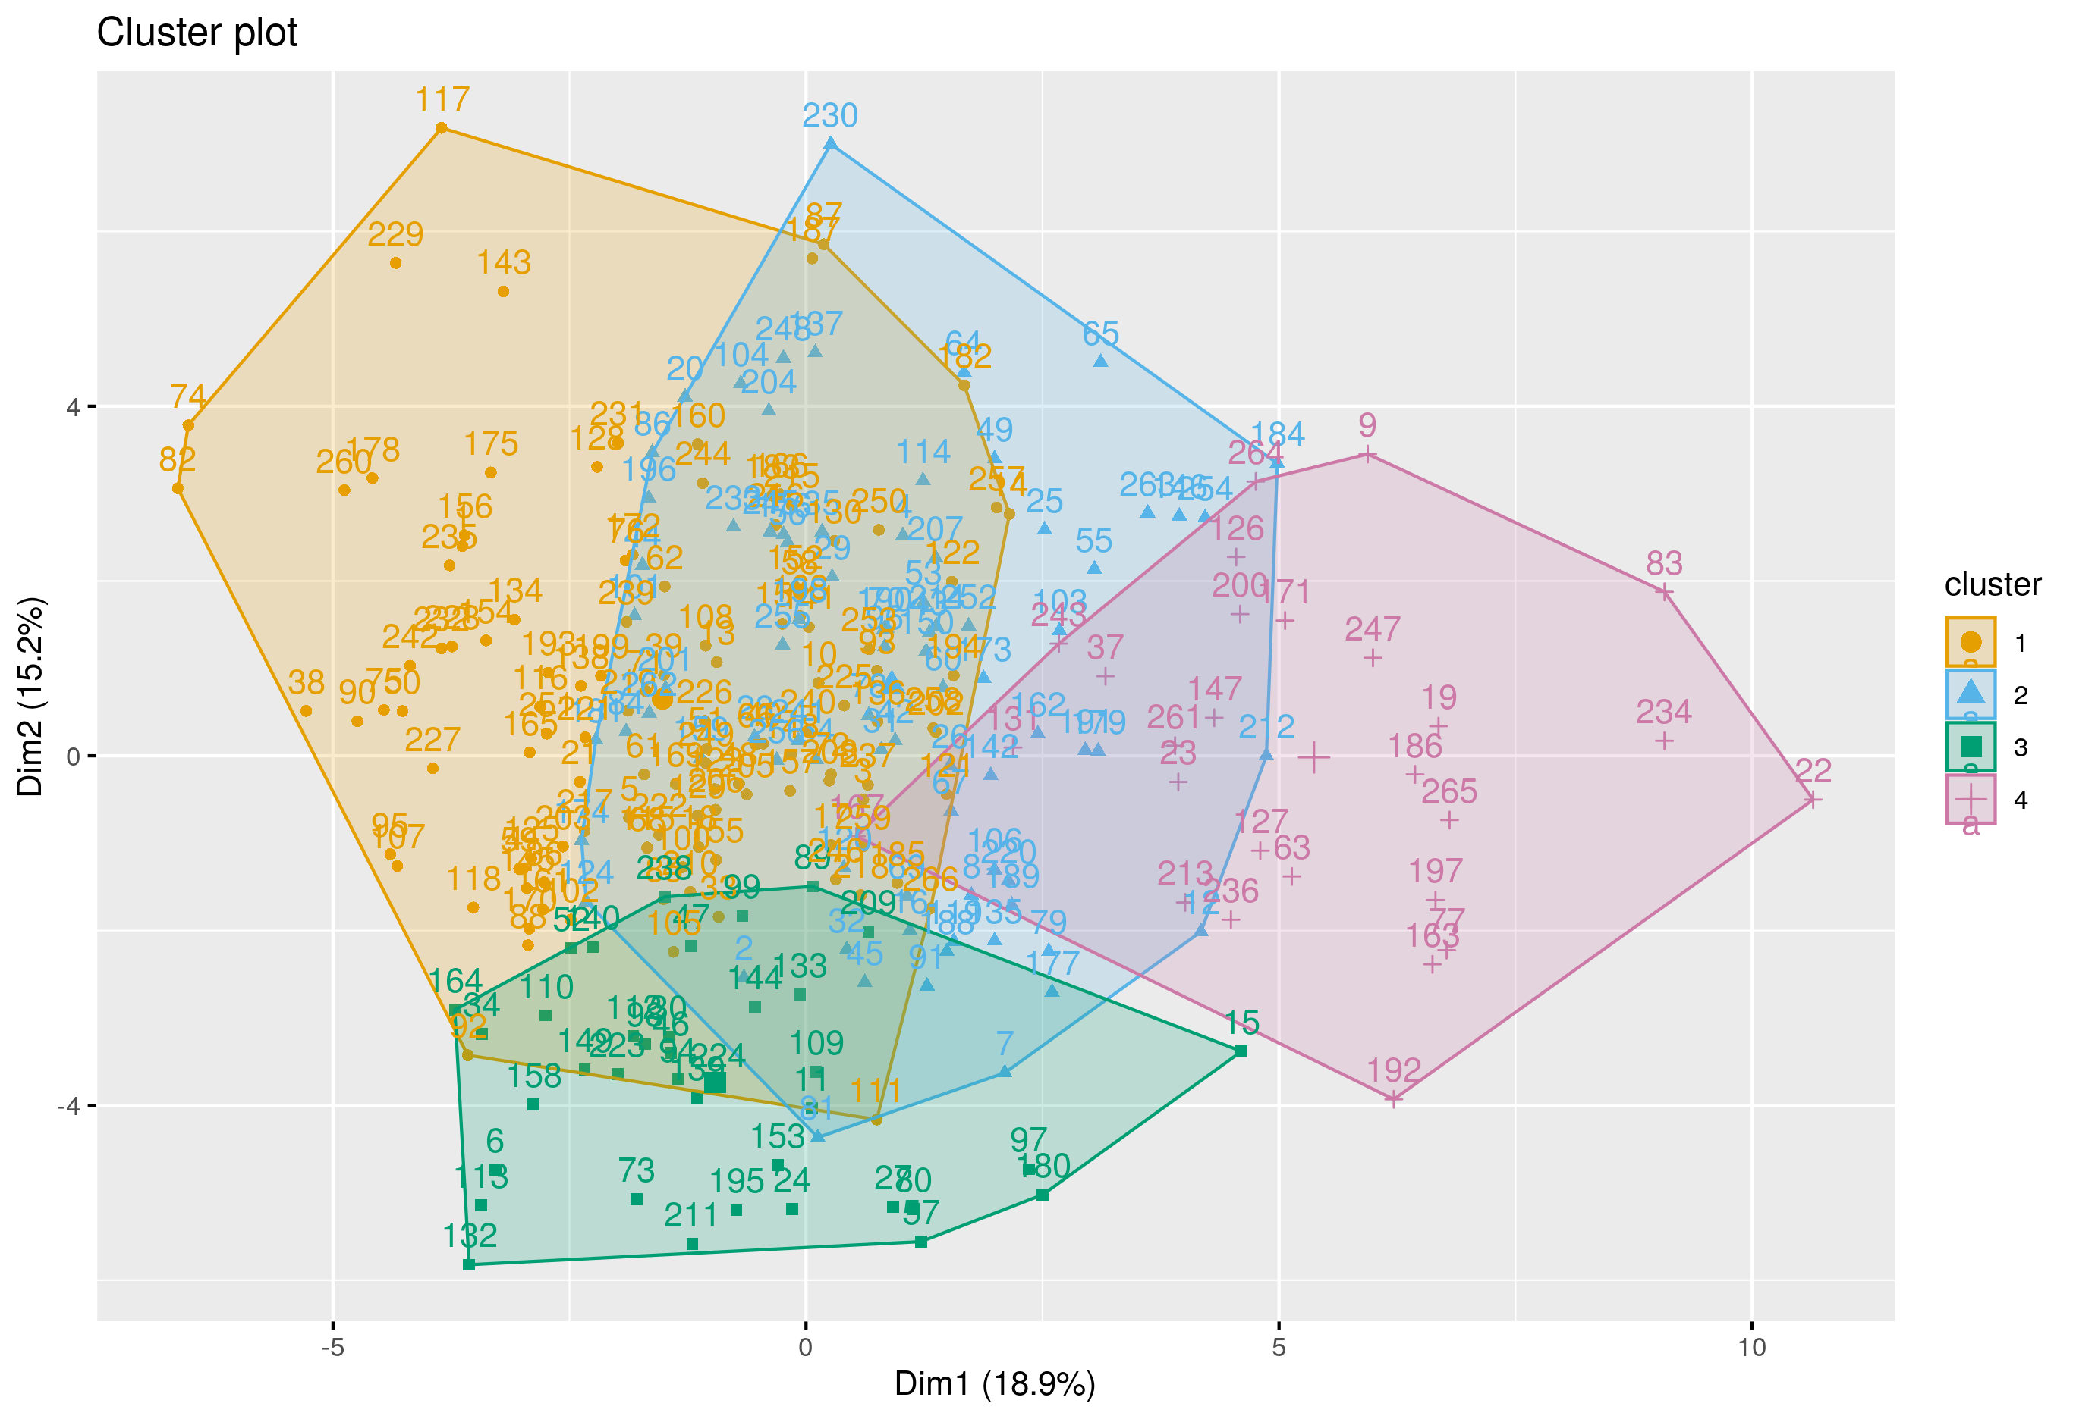

Radar plot
# radar plot data
radar_dat <- table1 |>
select(
SCAT5SymptmEvalTotSymptmScore,
symptom_exacerbation,
Sex,
`Days since injury`,
Anxiety,
Migraines,
symptom_provocation,
S1_SDNN,
S1_RMSSD,
Age,
AD,
AD_subjective,
grp4_cluster
) |>
rename(
Female = Sex,
`Pre-existing anxiety` = Anxiety,
`Pre-existing migraines` = Migraines,
`Symptom score` = SCAT5SymptmEvalTotSymptmScore,
`Tilt: symptom provocation` = symptom_provocation,
`Tilt: symptom exacerbation` = symptom_exacerbation,
`Pre-tilt: SDNN` = S1_SDNN,
`Pre-tilt: RMSSD` = S1_RMSSD
)
radar_dat <- radar_dat |>
group_by(grp4_cluster) |>
summarise(across(everything(), mean)) |>
ungroup() |>
mutate_at(vars(-grp4_cluster), rescale)
# radar plot
radar_plot <- radar_dat |>
ggradar(
group.colours = c("#E69F00","#56B4E9", "#009E73", "#CC79A7"),
fill = T,
legend.title = "Cluster"
)
# display plot
radar_plot
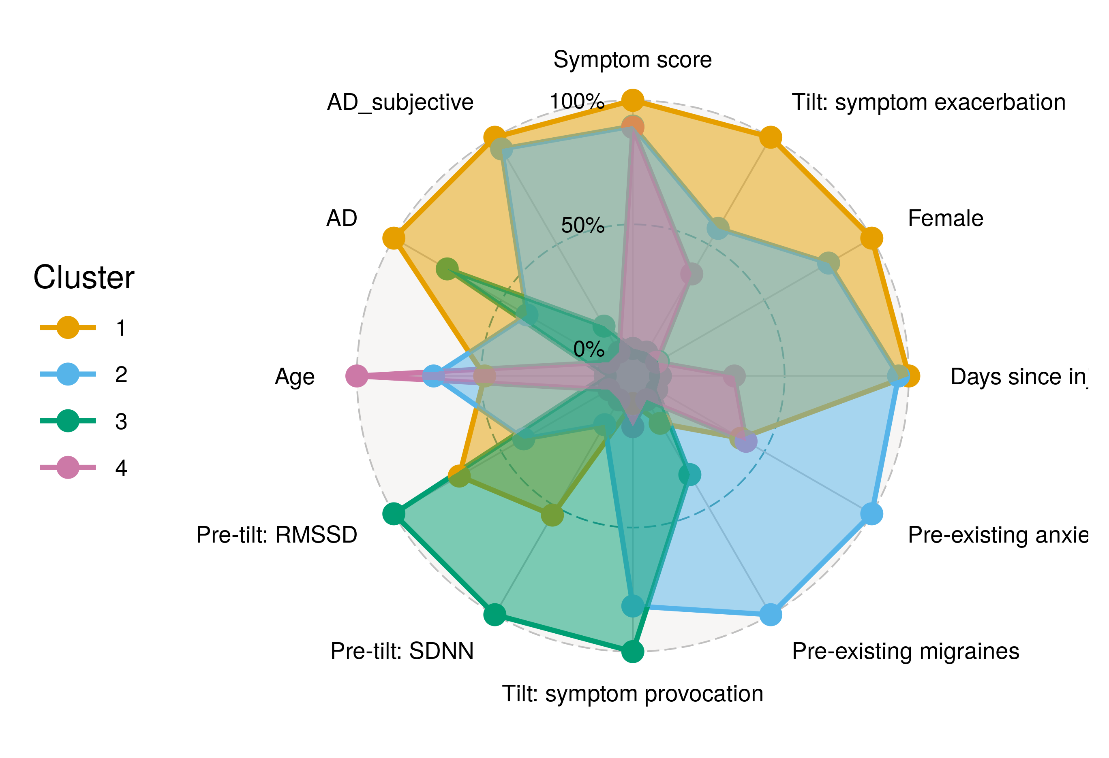

Heatmap
# select data of interest
scale_tilt.ortho_clust_subset <- scale_tilt.ortho_clust |>
select(Age, Sex, `Days since injury`, SCAT5SymptmEvalTotSymptmScore,
Migraines, Anxiety, TiltLyingHR,
symptom_exacerbation, symptom_provocation,
S1_SDNN, S1_RMSSD, clust_grp
)
# reformat
scale_tilt.ortho_clust_subset_mtrx <- scale_tilt.ortho_clust_subset |>
group_by(clust_grp) |>
summarise(
Age = round(mean(Age),3),
Female = round(mean(Sex),3),
`Days since injury` = round(mean(`Days since injury`),3),
`Symptom score` = round(mean(SCAT5SymptmEvalTotSymptmScore),3),
Migraines = round(mean(Migraines),3),
Anxiety = round(mean(Anxiety),3),
`Heart Rate (rest)` = round(mean(TiltLyingHR),3),
`Symptom exacerbation` = round(mean(symptom_exacerbation),3),
`Symptom provocation` = round(mean(symptom_provocation),3),
`Pre-tilt SDNN` = round(mean(S1_SDNN),3),
`Pre-tile RMSSD` = round(mean(S1_RMSSD),3),
.groups="keep") |>
ungroup()
# pivot data long
scale_tilt.ortho_clust_subset_mtrx_long <- scale_tilt.ortho_clust_subset_mtrx |>
pivot_longer(!clust_grp, names_to = "variable", values_to = "mean") |>
mutate(
variable = as.factor(variable),
cluster = as.factor(clust_grp)
)
# heat mapping plot
ggplot(scale_tilt.ortho_clust_subset_mtrx_long,
aes(x=cluster,
y=variable, fill=mean)) +
geom_tile() +
scale_fill_gradient2(low = "#56B4E9",
mid = "#FFFFCC",
high = "#CC79A7")
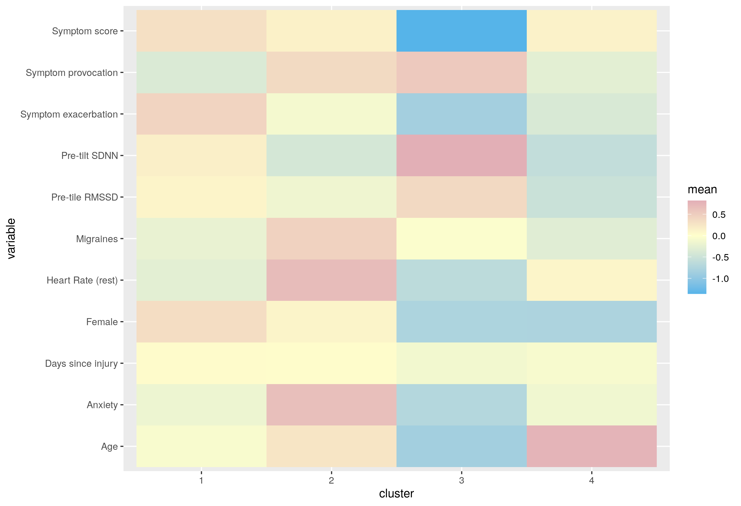

AD figure
sd_gts <- function(data, variable, ...) {
sd(data[[variable]], na.rm = TRUE)
}
# Pre-calculate means and sds and ll and il ci's then use ggplot precomputed stats
for_fig <- data_tilt.ortho_clust |>
select(
TiltLyingHR,
TiltStandingHR,
StandingHR_1_Minute,
StandingHR_2_Minute,
StandingHR_3_Minute,
clust_grp) |>
bind_cols(record_id) |>
rename(
`0` = TiltLyingHR,
`1` = TiltStandingHR,
`2` = StandingHR_1_Minute,
`3` = StandingHR_2_Minute,
`4` = StandingHR_3_Minute
)
record_id_subgrp <- for_fig |>
select(record_id, clust_grp)
for_fig_HR <- for_fig |>
select(-clust_grp) |>
pivot_longer(!record_id, names_to = "time", values_to = "HR") |>
mutate(
time = as.factor(time)
) |>
left_join(record_id_subgrp, by="record_id") |>
group_by(time, clust_grp) |>
summarise(
HR_mean = round(mean(HR),2),
HR_sd = round(sd(HR),2)
) |>
ungroup()|>
mutate(
n = case_when(
clust_grp == 1 ~ 120,
clust_grp == 2 ~ 81,
clust_grp == 3 ~ 38,
clust_grp == 4 ~ 27
),
HR_margin = qt(0.975,df=n-1)*HR_sd/sqrt(n),
HR_ll = round(HR_mean - HR_margin,2),
HR_ul = round(HR_mean + HR_margin,2),
clust_grp = factor(clust_grp),
time = factor(time, levels=c("0", "1", "2", "3", "4"),
labels=c(
"Rest",
"0", "1", "2", "3"
))
)
pos_jit <- position_jitter(width = 0.05, height = 0.01, seed = 123)
colScale <- scale_colour_manual(name = "Cluster",values = c("#E69F00","#56B4E9", "#009E73", "#CC79A7"))
figure <- ggplot(for_fig_HR,
aes(x = time, y = HR_mean,
colour=clust_grp,
group = clust_grp)) +
geom_errorbar(aes(ymin = HR_ll, ymax = HR_ul),
width = 0.05,
position = pos_jit) +
geom_point(shape = 'square', size = 2, position = pos_jit) +
geom_line() + # position = pos_jit
geom_jitter(position = pos_jit) +
theme_classic() +
xlab('Time (mins)') +
ylab('Mean heart rate (bpm)') +
colScale
# print figure
figure
